


DRAFT REPORT
Development of Dielectric Sensor System on
Intelligent Amphirols for Mud Farming Tailings Facilities

Project Partners:
Phibion Pty Ltd
158 Benjamin Place
Lytton, 4178
The University of Queensland
Brisbane St Lucia, QLD 4072
Funded by:
Australian Government
Department of Industry, Innovation and Science
Innovation Connections & Cubis Systems

Background and Project Aim
The recent failures of tailings storage facilities (TSF) have once again revealed their structural weaknesses and technical insufficiencies, and the threats that are posed by these unique structures to life and limb, our environment and the economy. Statistics have proven that TSFs fail more frequently than similar structures used as water storage facilities. The main reason for the higher probability of failure of TSFs is the lack in sufficient compaction of the tailings material during deposition and the subsequent consolidation. The threats posed by TSFs could be significantly reduced if the tailings material could be more effectively compacted already during deposition.
One possibility to improve compaction of tailings is mud farming using amphirols. These amphibious vehicles move using two Archimedean spirals. The vehicle can float in pure water and operates for very thin suspensions like a motor boat. With increasing compaction when soil properties start to influence the performance of the amphirol, the operation becomes similar to a tracked vehicle. Early operation of the amphirol allows the tailings material to reach higher compactions due to:
- Drainage of water to the surface, from where it can flow due to gravity to a drainage channel,
- overcoming of hindered sedimentation, which prevents further consolidation due to self-weight only, and
- increased evaporation as the surface is kept water saturated and thus evaporation at its maximum.
Operation of the amphirol starts ideally with the deposition of the tailings material. At this stage, the suspension is rather thin and behaves viscous. With ongoing operation, the solid concentration in the suspension increases and the suspension is reaching a soil-like state, where friction starts to dominate the overall material behaviour. Also controlling and operation of the amphirol changes and requires more skilful operators. With increasing suspension density, the draught of the amphirol decreases until the efficiency of additional overruns is significantly reduced. Operation of the amphirol is stopped at this stage, or when a sufficient shear strength of the soil is reached.
The most important parameter for quality control during amphirol operation is the density of the tailings material. So far, there is no indirect and non-invasive method available that allows the measurement of the tailings density. Density measurements using samples is laborious and not representative if only few samples are taken. Therefore, to date substitute parameters have been observed that are linked to the density, such as torque and fuel consumption. However, these are insufficient parameters to quantify the density of tailings materials during operation of an amphirol.
In order to fill this gap, Phibion Pty Ltd (former known as Residue Solutions) and researchers from the University of Queensland (UQ) from the Schools of Electrical Engineering and Civil Engineering have compiled this project to develop an electromagnetic measurement monitoring method based on the antenna technology. Investigations at UQ on various soils, dredged material and tailings materials have shown that electromagnetic methods can be used to quantify the water content from the dielectric permittivity with sufficient accuracy.
The free water in a soil/water mixture dominates the dielectric permittivity in the radio to microwave frequency range. Based on laboratory investigations, calibration functions can be developed for determining the water content from the dielectric permittivity. Since tailings material is fully water saturated throughout the operation of the amphirol, the water content can directly back calculated into the density when the specific gravity (the dry unit weight of only the solid phase divided by the unit weight of water) is known.
The Innovation Connections grant was established by Phibion and UQ to fund the first steps in the development of an autonomous system for measuring the density during the operation of amphirols. The project aimed to develop a method for quantifying in real time the density of soil waste and soft soil based on electromagnetic measurement results to improve TSF management and safety:
- In the first stage, a specifically designed RF architecture (include the contactless dielectric probe) in the theoretical level had to be developed in the EM simulation and laboratory environment;
- In the second stage, a proof-of-concept prototype as a minimum viable product (MVP) had to be built and tested in the real environment for collecting the measurement data, and reshaping the data into the form representing the dielectric properties of the soil wastes.
The following outputs have been defined for the Innovation Connections project:
- Develop antennas for measuring the relative complex dielectric permittivity of soils and soil waste for targeted frequency windows.
- Determine the dielectric spectra for selected tailings materials to quantify the targeted frequency windows that can be used to quantify the density of the tailings.
- Integrate the antennas into the existing on board system including data transfer.
The presented report summarizes the works that have been conducted to achieve the objective and to produce these outputs. Both partners, Phibion and the involved researchers at UQ are keen to further advance in this collaboration and to complete the monitoring system started with this Innovation Connections grant.

Overall Approach
Measurements of dielectric properties using antenna is inherently different from dielectric measurements using probes. While using probes the created electromagnetic (EM) field is either contained within the probe or restricted in its extension can the radiation produced by the antenna interact with its entire environment and that depending on the frequency. Because of this reason, the scattering parameters are usually not further computed to derive a dielectric permittivity, but analysed in a way to show e.g. differences in dielectric spectra.
For the underlying problem of this proposal, it is a necessity to determine the dielectric permittivity from the antenna measurements. One possible approach is to use self-learning strategies to create a connection between the scattering parameter (S₁₁, directly measured with the antenna) and the dielectric permittivity of the ground. Based on this approach, the following working steps have been implemented within this project:
- Development and characterization of an antenna.
- Forward simulations using the characteristics of the antenna within the dielectric permittivity range to be expected for tailings and the surface conditions during the operation of the amphirol.
- Development of an experimental set-up that allows the application of the antenna in an array under realistic application conditions.
- Implementation of a test with quantification of the conditions using accompanying sampling.
- Analysis of the test results and comparison with onsite sampling.
- Integration of the system in the existing data acquisition system for amphirols at Phibion.
In the following, the outcome of the project according to these working steps are presented.

Machine Learning Approach with Neural Network

Motivation
It is important to note that the surface of the soil within a TSF varies significantly especially during the operation. For a non-invasive method, the sensor, i.e. the antenna, needs to be placed in air and radiates towards to the soil. This means that the data collected will be strongly affected by this large variation of the soil surface. Therefore, conventional methods such Ground Penetrating Radar (GPR) will face a significant challenge.
Using Machine Learning (ML) approach, a large number of data sets can be collected, which takes into account the randomness of the soil surface. Furthermore, the ML approach can also take into account other variable parameters and conditions, such as the distance from the antenna to the soil surface. More importantly, the accuracy of ML approach will keep improving as more and more data sets are collected (provided accurate measurements of the water content/permittivity of the soil at these locations).

Approach
To obtain the permittivity of the soil, we need a set of data that is dependent on this permittivity. This set of data is the reflection from the soil when transmiting an electromagnetic signal from an antenna that is attached to the Mudmaster. The more data, i.e. the more information, is collected, the higher is the chance that we can obtain the permittivity accurately. It is noted that the data set needs to be “clean”, i.e. it is distinguishable from the system noise. All these conditions can be achieved by:
- Using a wide range of frequency, i.e., wideband antenna. Each frequency can provide different information of the reflection of the soil.
- Using more antenna elements. Fig. 1 shows that the application of two antennas allows reflection measurements from the soil obtained by transmitting and receiving form each antenna, as well as the reflection obtained from Antenna 1 when transmitting from Antenna 2 and vice versa.
- Using a highly directive antenna with the main beam pointing towards to soil so that a larger reflection from the soil can be captured.
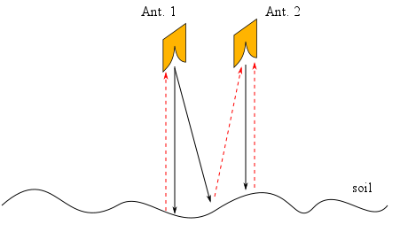
Figure 1: Measurement setup with two antennas on soil with random surface.
Based on points (i),(ii) and (iii), the choice was to use a wideband antenna array with a directive beam pointing towards to soil. Using this system a large number of data sets will be collected where:
- The permittivity of the soil is known, and
- each data set will have a random soil surface, random distance from the antenna to the soil surface, and a small variation in the antenna position (which is due to the operation of the Mudmaster).
Then these data sets will be used to train a Neural Network. The Neural Network will be then use to predict the permittivity of the soil. With more data sets, the accuracy of the Neural Network will be improved.

Simulation
- Antenna Design
For a wideband, directive and compact antenna, the Vivaldi antenna is chosen. The antenna design is shown in Fig. 2. The dimension of the antenna is (in mm):
$L = 170.17, W=172, w_{1}=104, w_{2}=144.83, g=1.67, R_{1}=22.07, R_{2}=22, L_{1}=56.17$.

The open aperture of the Vivaldi antenna is exponentially tapered with a function in the form of
$$y=C_{1}e^{rx}+C_{2}$$

The constant $C_{1}$ and $C_{2}$ can be easily determined from the geometry of the antenna in Fig. 2. The optimized exponential rate is $r=0.06035$.

The simulated S-parameter (S₁₁) of the antenna in free-space (air, without soil) is shown in Fig. 3. As can be seen from Fig. 3 the antenna achieves a wide bandwidth from about 0.6 GHz to more than 3 GHz (please see also note below Fig. 3).

Fig. 4 shows the simulated 3D radiation pattern of the antenna at different frequencies. The pattern is more directive at higher frequencies. The antenna can be designed with higher directivity but a larger dimension needs to be used.
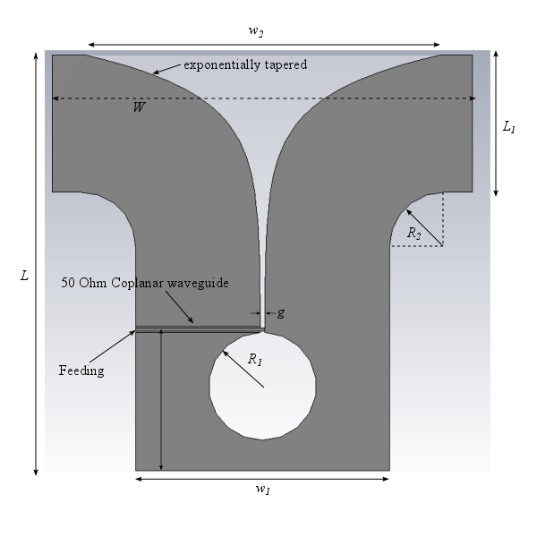
Figure 2: Antenna Design
Figure 3: Simulated antenna reflection coefficient (|S₁₁|)
Figure 4: Simulated antenna radiation pattern at different frequencies
- Calibration
When antenna radiates towards the soil, S₁₁ will consist of two components: the reflection from the antenna itself (the one shown in Fig. 3) and the reflection from the soil (which is the infomation required to quantify the water content). The latter is much smaller than the former. In order to obtain the reflection from the soil, calibration has to be performed. In simulation, this is achieved by substracting the two curves,
$$R=S_{with soil }-S_{w/o soil}$$
Figure 5: Simulated raw data and calibrated data
Where $S_{with soil }, S_{w/o soil}$ are the S-parameter measured by the antenna with and without the presence of the soil. By doing this, all effects from the antennas are removed and a data set $R$ is obtained which contains just the reflection from the soil. Fig. 5 shows the simulated raw data ($S_{with soil }$) and the calibrated data $R$. The calibrated data $R$ is in range of about -30 dB which much smaller than the raw data (about -10 dB).
- Results
As a first step, about 1000 data sets are simulated in a forward approach with a two antenna array. Soil surface, soil permittivity, and distance from the antenna to the soil surface are chosen randomly Fig. 6). These data sets are then separated into a training set and a testing set.

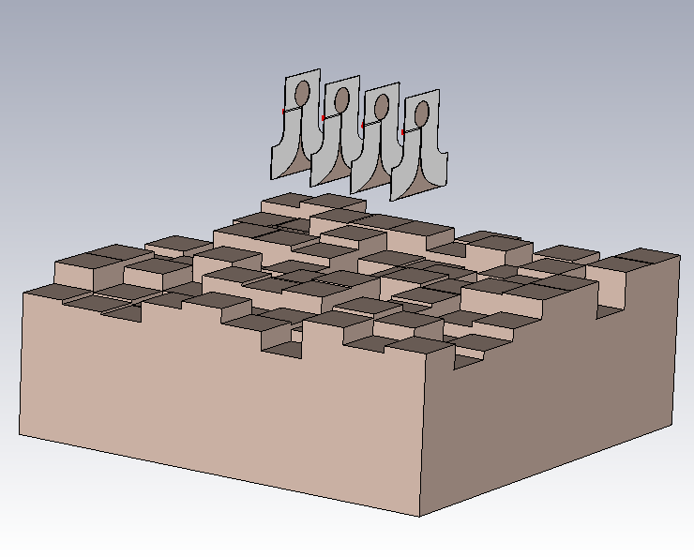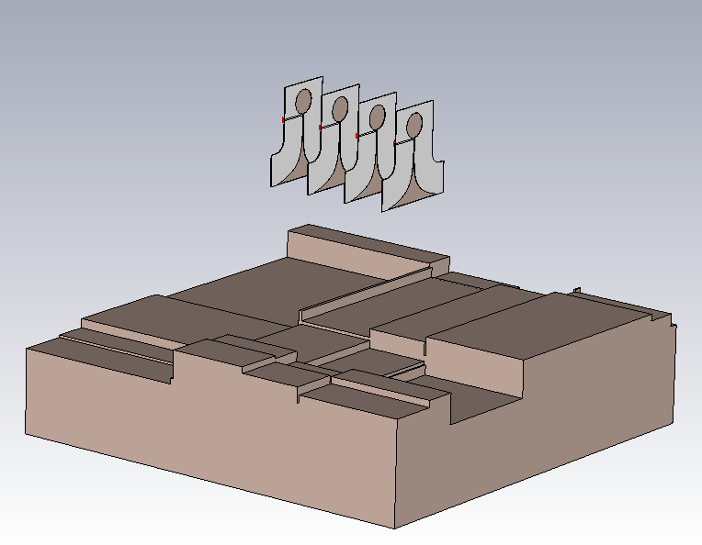
Figure 6: Simulation Environment (CST) with random soil surface
Fig. 7 shows exemplarily the results of the forward simulation of the testing set versus the predictions using the Neural Network. For comparison with the experiment result later, the simulated results are obtained with data from only two antennas although the simulation is done originally with 4 antennas.

The comparison in Fig. 7 shows clearly that the Neural Network is able to predict the permittivity with high accuracy. This means that the Neural Network can take into account the randomness of the soil surface and distance from antenna to the soil, which is extremely challenging to achieve using conventional methods, such as GPR.

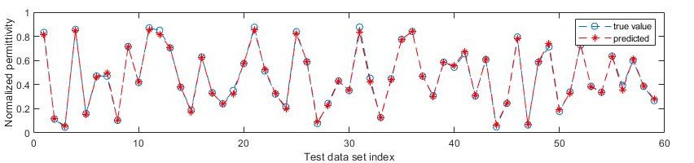
Figure 7: Results using Neural Nework to predict the soil permittivity with random soil surface, random distance from antenna to the soil.

Experiment
- Experiment Setup
The experiment setup is shown in Fig. 8. It consists of two Vivaldi antennas with fixed cables (i.e. attached to the metal holder arms), which connected them to a vectorial network analyzer. The distance from the antenna to the surface of the soil is about 50 cm. A 3m by 3m pond with a depth of 30cm was built, sealed with a liner, and filled with dredged soil from the Port of Brisbane. One set of data was collected in each 15 minutes.

The measurement was conducted over a duration of three weeks. The dewatering was accelerated using fans leading to a gradually decrease of the water content of the soil. Accompanying local dielectric permittivity measurements have been conducted with another VNA, and samples have been taken regularly to determine a dielectric permittivity/water content relationship in the laboratory.
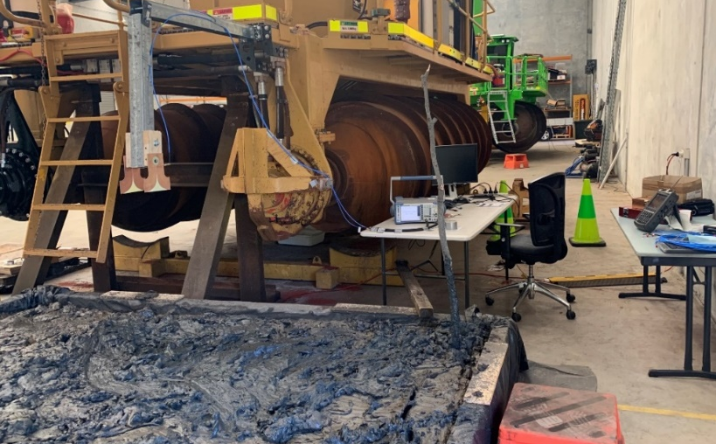
VNA for local measurement
VNA connected to antennas
Soil Sample
Antenna
Figure 8: Experiment setup
- Calibration
For the calibration of the antenna measurements, absorbers for radio frequency measurements have been placed on top of the mud pond. These RF absorbers will absorb the RF power radiating from the antenna targeted at the soil surface. This step is done to obtain the $S_{w/o soil}$ measurement as it was done within the simulation.

Fig. 9 shows the experimental setup to measure $S_{w/o soil}$. It has to be noted that the absorber placement is not perfect, so that each arrangement of absorber can yield different set of calibration data ($S_{w/o soil}$). This aspect has to be taken into account when building the Neural Network.

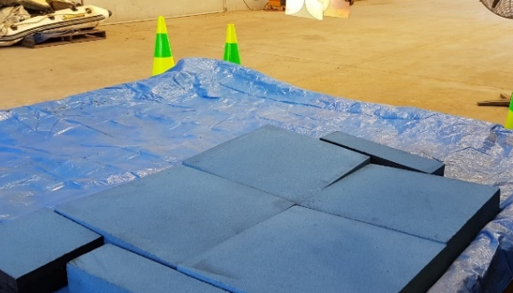 | 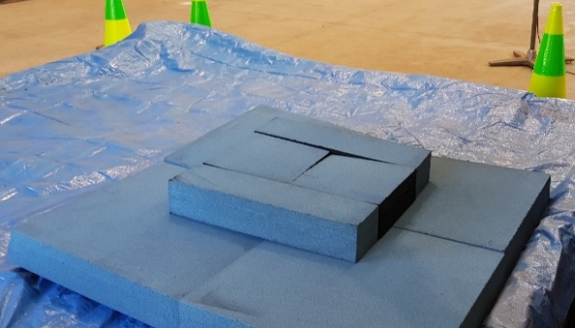
Figure 9: Calibration with RF Absorbers (two different setups for the absorbers)
Fig. 10 shows the calibrated data using different absorber arrangements. These resulting data show some difference mainly in the lower frequency range due to the imperfect arrangement of the absorber. The level of calibrated data is around -30 dB which agrees with simulation.
The measured calibrated data shows more fluctuation compared to the simulated one in Fig. 5. This is due to the effect of the surrounding environment, especially the antenna holder which was not taken into account in simulation. In order to take these effects into account in the physical experiment, the antenna have been mounted to the amphirol. It can be expected that without the presence of the amphirol, i.e. the antenna mounted only to a frame, the measurement results would have been different.
Figure 10: Measured raw data and calibrated data with different absorber setups
- Soil Permittivity Measurement
The temporal evolution of the water contents of the samples that have been taken during the test is shown in Fig. 11. For the usage of these data to train and later test the Neural Network, it can justifiably assumed that the water content does not change significantly within one day.

As can be seen from Fig. 11, there is quite a scattering of the data, which is caused by the fact that the location, where the samples have been taken varied and that the surface was regularly changed to accommodate this influence in the experiment. Because of that reason, the measured data is fitted to a sum of two exponential functions with the form of

$$y=ae^{bx}+ce^{dx}$$

Parameters are determined as $a=38.65, b= -0.09473, c=67.38, d=0.001218$, where $x$ is the time of sample collection ($x = 0$corresponds to 12:00 am on 15/07/2021) and $y$ is the water content in percentage.

Since the samples were collected at different locations at different times, some variations in the measurements can always be expected and are only manifestations of the inherent natural variability. Nevertheless, since water content is expected to gradually decrease with time, the fitted curve in Fig. 11 provides a reasonable representation of the water content during the experiment. The root mean square error (RMSE) in the curve fitting is 4.949. Thus, an estimation for error in this water content measurement is about 5%.
Figure 11: Measured water content using gravimetric method on samples collected
from the mud pond during the duration of the experiment.
The collected samples have been analysed in the laboratory with probe measurements to obtain the corresponding permittivity. Fig. 12 shows the measurement results. The blue curve and corresponding points are the data for this experiment. A dataset that has been collected in 2017 at the Port of Brisbane is also plotted for comparison. It can be observed that – even from the same location at another time – different soil samples may have different electromagnetic behaviours, i.e. the rate of change in permittivity with water content is different. This observation highlights the need for a rigorous calibration strategy to maximise the accuracy of the antenna measurements.

The permittivity used in Fig. 12 to show its dependency on the water content is shown for a frequency of 1 GHz. It should be noted that the permittivity does not change much around this frequency range (see Fig. 13) and reflects the free water contribution in the soil\water mixture. Therefore, it is justified for the analysis to use this permittivity as the expected average permittivity of the soil in the considered frequency range covered by the antenna array (0.7GHz up to about 2 GHz).

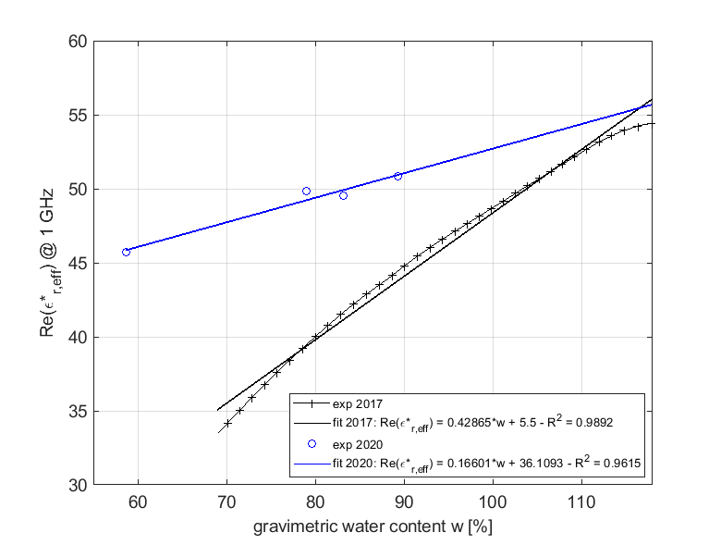
Figure 12: Measured permittivity at 1GHz of the soil sample for different water contents.
Data set from 2020 has been collected from the mud pond during the experiment,
and the data set from 2017 was from taken from the Port of Brisbane.
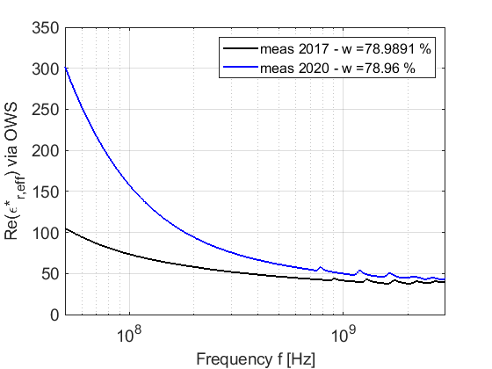
Figure 13: Measured permittivity from the sample versus frequency.
In frequency range around 1 to 2GHz, the permittivity is almost constant
In combination, the measurement results from Fig. 11 and Fig. 12 allow the determination of a dielectric permittivity at 1GHz that can be used to train and test the Neural Network for the measurements taken with the antenna array.
- Results
The measured data with the antenna array is separated into two sets of data: a training set and a testing set. For this purpose data are used that have been collected from 20/07 to 06/08 with 1419 data points. During this time, the surface of the soil within the pond was changed daily to take into account the soil surface randomness in the Neural Network.

Fig.14 shows the result of the Neural Network in form of the dielectric permittivity trained on a set of data with the first calibration setup (the left photo in Fig. 9). The top figure shows the performance of the Neural Network during training, and the graph below shows the predicted permittivity versus the true value. It can be seen that the Neural Network can predict very accurately the permittivity of the soil.

Although the results of Fig. 14 are very encouraging, it has to be emphasized that this result only represents this experiment setup and calibration.

The same Neural Network obtained as in Fig. 14 used on the data with a different calibration setup (different arrangements of absorbers like in Fig. 9 right) produces a completely different picture shown in Fig. 15. It can be seen that due to the imperfection of absorbers, the Neural Network does not produce an accurate result. It must be noted that this kind of result must be expected if there is any variation in the experiment setup, such as antenna position relative to the Mudmaster, the depth of the mud. This fact highlights again the importance of a rigorous procedure for the calibration of the antenna array.

One possibility to resolve this issue is to take this uncertainty into account in the training of the Neural Network. Therefore, data sets from different calibration setups have been combined to create a new Neural Network with a larger number of data sets (1419*3 = 4257 set of data). The results are shown in Fig. 16. The Neural Network can again predict very well the permittivity. Since we take all different calibration setups into account, this Neural Network is much more robust than the one in Fig. 14.

In conclusion, the accuracy of the Neural Network can significantly be improved when more data for different situations are collected (e.g. for different type of mud, larger variations in the soil surface, etc.).

Figure 14: Results from the training set (top) and testing set (bottom) using Neural Network
on a set of data with the first calibration setup.

Figure 15: Results from the Neural Network obtained on Fig. 14 with different data sets calibrated
from different arrangement of absorber. Top: with just a slight variation on absorber position,
Bottom: a larger variation of absorber position.
Figure 16: Results from a new Neural Network with a lager data set
formed from all different calibration setups.
- Prediction of water content and density
Ultimately, the set-up needs to prove its capability to predict the evolution of the water content as well as of the dry unit weight. Fig. 17 shows the reconstructed water content (using the Testing Data only) for the duration of the experiment. The measurement results from samples taken during the experiment (see Fig. 11) are also plotted for comparison. For this comparison, only data from Day 5 to Day 23 are used because:
- The data from Day 0 to Day 4 at the beginning of the measurement are not consistent with the experiment from Day 5.
- The data from Day 23 to Day 27 are not available due to a connection error from the laptop to the Vector Network Analyzer (VNA).

As can be seen from Fig. 17, the prediction corresponds very well with the data of the water contents taken during the experiment, which is pleasing, but at the same time also not surprising as the measured data have been used to train the Neural Network.
The dry unit weight in kN/m³ can for fully water saturated conditions simply calculated from the water content using the equation
$$γ_{d}=\frac{Gγ_{w}}{1+ \frac{wG}{S}}$$
Where G = 2.57, w = water content, S = 1, $γ_{w}=9.81 ×{10}^{3} N/m^{3}$. The resulting Fig. 18 shows the dry unit weight with time of experiment. Although the dry unit weight has changed only insignificantly, the strength of the soil increased as the workability of the soil changed significantly during the test. In future experiments, undisturbed soil samples need to be taken for comparison reasons.
Figure 17: Reconstructed Water Content
Figure 18: Dry unit weight versus time of experiment

Discussion, Conclusion and Outlook
The presented results developed within the innovation connections grant show clearly that it is possible to measure the dielectric permittivity non-invasively using an array of antennas. Within this project the following developments have been made:
- An antenna for measuring the scattering parameter S₁₁ over a frequency range of 0.6 GHz to more than 3 GHz.
- A Neural Network approach for quantifying the dielectric permittivity from the S₁₁ parameters based on numerical simulations using realistic parameters for the dielectric behaviour of soils and under consideration of surface variations to be expected during the operation of an amphirol.
- A procedure for calibrating the antenna under realistic and therefore quasi field conditions.
A large-scale experiment at the premises of Phibion has been implemented. The conditions during this experiment had to be as realistic as possible in terms of the mounting of the antenna at the amphirol to take into account the presence of the machine during EM measurements and with respect to the ground condition to minimize the influence of the concrete ground on the measurement results. Therefore, a mud pond 3 m by 3 m in size and with a depth of 30 cm has been built and sealed using a plastic liner. The following findings can be summarised from this experiment:
- The dielectric permittivity was quantified with satisfying accuracy based on samples taken during the experiment.
- The calibration of the antenna plays an important role in the final accuracy of the determination of the dielectric permittivity from the S₁₁ parameters using the Neural Network.
- By using a soil-specific calibration function, the water content could be determined, which could then be used to compute the dry unit weight of the soil sample.
All in all, the outcome of the experiment at Phibion are satisfying and have proven the applicability of antenna arrays in combination with a suitable analysis method based on self-learning algorithms and accurate ground measurements to quantify the water content and the dry unit weight of soils.
There have been also important learnings that have to be considered in future investigations:
- In future laboratory experiments, undisturbed samples have to be taken in a way to instantaneously measure both, water content and dry unit weight. The containers used in the experiment described above have been not fully airtight, so that the water content had changed over time.
- A mounting mechanism for the antennas has to be developed that will ultimately also be used in situ. An important aspect is the fixture of the cables on the machine, which should be realized using semi-rigid cables to avoid influence of vibration on the measurements.
- The VNA to be used in the field needs to be integrated into the on board measuring system to be able to take into account the performance of the used measurement device. First steps in integrating the field deployable device to the existing system have been made, but problems with arranging the continuous measurement have delayed the completion of this step.
- Ground measurements of the dielectric permittivity has to be implemented with more probes to receive a larger coverage of the area and to produce representative measurement results to train the Neural Network.
In order to allow the integration of the antenna measurements in the automation of the amphirol and for enlarging the information content for deriving further parameters from EM measurements, the following aspects have to be considered in future investigations:
- Development of calibration procedures including devices and sensors for calibrating the antenna system and the tailings material in situ including the mechanical parameters.
- Quantification of the accuracy of permittivity, water content and dry unit weight measurements.
- Development of a model to be able to predict the operation time of the amphirol to reach a targeted stage of the tailings.
- Development of a database of calibration functions for various tailings materials over a broad frequency range.
- Development of measurement strategies for covering the lower frequency range providing the opportunity to quantify e.g. clay content, mineralogy, particle size distribution and metal content.

Technical Note: S₁₁ is the reflection coefficient of the antenna. S₁₁ = 0 dB means all RF power is reflected to the port and the antenna doesn’t radiate. When S₁₁ < -10 dB, less than 10% of RF power is reflected back to the port, which means the antenna radiates efficiently with more than 90% of RF power.
Note: the raw data in Fig. 5 is slightly different from the results in Fig. 3 because Fig. 5 simulated an array of antenna where the adjacent element affects the overall performance while Fig. 3 just simulates a single antenna
Note: The frequency dependence of the soil samples from 2017 and 2020 also differ significantly suggesting that probably the salinity of the sample from 2020 was higher than in 2017.
At that time, testing procedures have not been harmonized with the dewatering of the sample.
Data have been checked on Day 28 (12/08) and issue was fixed. From Day 28 data are available, but since the water content did not change much, these data have not been included in the Neural Network.

